CSE 111 Fall 2010
Midterm Study guide

Lecture 2.
Four factors for a successful product
  - Iterations: develop part of the functionality, explore designs such as GUI
  - Daily builds: incorporate new code into (partially) complete system; rapid feedback via testing
  - Team experience in shipping multiple products
  - Early focus on building and evaluating a cohesive system architecture
Kinds of requirements: the FURPS acronym
  - Functionality
  - Usability
  - Reliability
  - Performance
  - Supportability
Our use cases focused on functionality

Lecture 3
What is Model View Separation?
Model View Controller?
(Diagrams for the above)
Three-tier system architecture?
Layers pattern or system design property?
What is a subsystem - Package plus one or more interfaces that define the services supported by the subsystem

Lecture 4.
Kinds of concepts (concept categories) that may appear in a domain model
- Physical Objects: user, member
- Descriptions: personal props, prefs., dates
- Roles: member, dater, administrator
- Containers: DS Data Base
- Organizations: DS Accounting Dept.
- Events: logon, getADate, SetMemberData
- Abstract nouns: session
Kinds of domain model relationships
- A is a physical or logical part of B
  - E.g. Personal Characteristics are part-of Dater Properties
- A is physically or logically contained in B
  - E.g. MembershipData contained-in MemberDB
- A is described by or identified by B
Special event-oriented relationships
Does and Don'ts for domain models
Should be a static model, not a dynamic flow chart
Should have real world concepts, not software entities
Over do it in terms of concepts, rather than under do it
Be able to draw and/or interpret a give domain model

Lecture 5a
Consider the following diagram

1. Does this describe a scenario in which there are subcases, i.e. alternative sub-scenarios? Explain.
2 Does the diagram conform to a "layers" oriented design? Explain
3. Which object, in order of time, sends both the first and the last message?

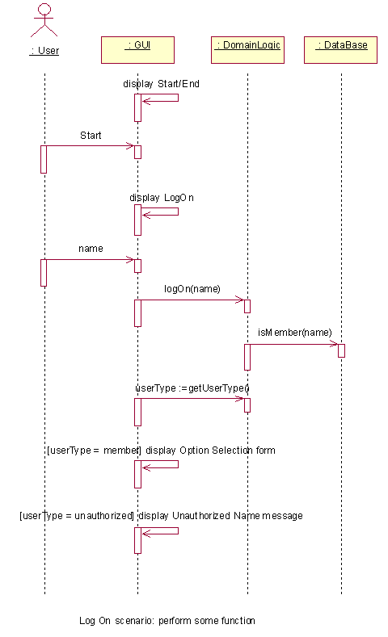

Lecture 5b
Give brief definitions for the following:
Expert pattern
Object animation

Lecture 6
Consider the following collaboration diagram
1. What are the condition(s) under which GUIFrame asks the DomainLogic subsystem for the type of the user currently logged on?
2. What do you think the constructor parameters are for the MessageDialog (sub)class that is indicated in the diagram?
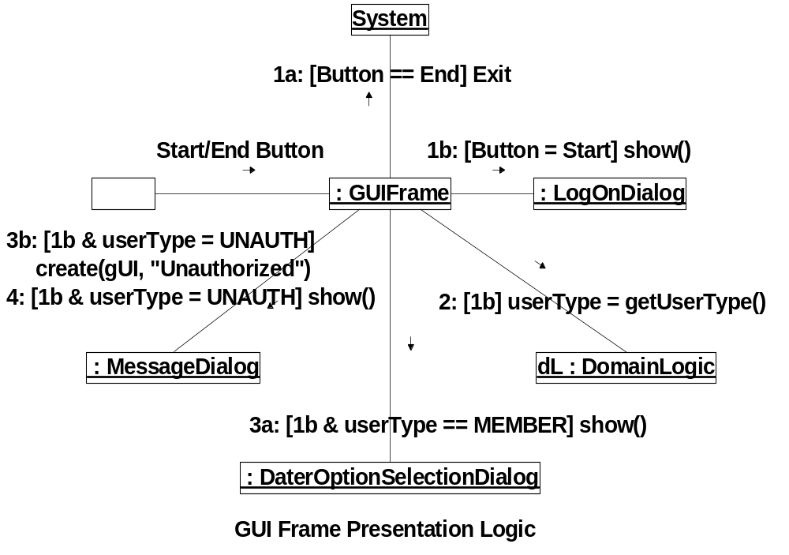

3. Consider the following diagram
In the top collaboration model, there is a create() message being sent to the object on the right. Does this satisfy the creation pattern? Justify your answer.
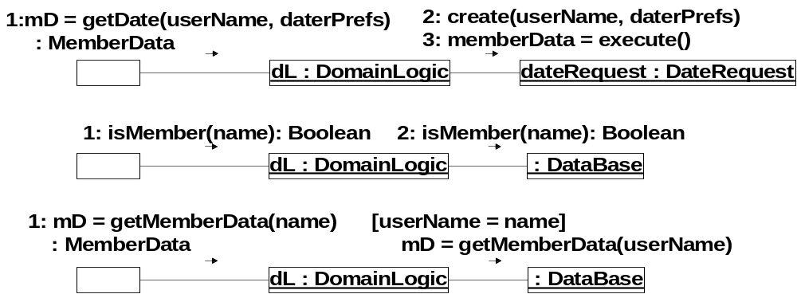

Lecture 7
1. When one object "sends a message" to another object in a design diagram, then the first object has to "see" the second object. We identified 4 kinds of visibility implementations that could be used to satisfy such a requirement. One of these was global visibility. What were the other 3?

3. In the design for the DS, there is an object visibility issue where the main GUI object needs to send messages to the DomainLogic interface class. This implies an object visibility requirement, from GUI to DomainLogic, that has to be integrated into our design. Suggest a way of doing this (do not use the names for the different kinds of visibility, just a description of how to do it).

Lecture 8
1. Give a short description of each of the following kinds of component cohesion.
a) Coincidental
b) Logical
c) Data Flow
c) Communicational

2. Rank, in terms of desirability, the following levels of Class Cohesion (1-3)
_______ class responsible for many things in very different functional areas
_______class has moderate responsibilities in one functional area, cooperates with others to fulfill more complex responsibilities
_______ class responsible for many or complex things in one functional area

3. In structured programming, the method of composing simple structures to get more complex structures uses a certain kind of operation. What is it?

4. Sometimes you hear the statement that structured programming is the same thing as "go to less" programming. Is this true? Explain.

